

Final Project

BMU Verification Plan

Context

- List Of Abbreviations

- Introduction

- Design Overview

- Verification Strategy

- Testbench structure

- Verification Extra Details

List Of Abbreviations

Abbreviation | Definition
BMU | Bit Manipulation Unit
UVM | Universal Verification Methodology
DUT | Design Under Test
RTL | Register Transfer Level
OP | Operation
RISC-V | Reduced Instruction Set Computer Version 5
Zbb | Basic Bit Manipulation Subset
Zba | Address Calculation Bit Manipulation Subset
Zbs | Single Bit Manipulation Subset
Zbp | Permutation Bit Manipulation Subset
SRL | Shift Right Logical
SRA | Shift Right Arithmetic
MSB | Most Significant Bit
CSR | Control Status Register

Introduction

Goals (Purpose) of this document

Scope of verification

Assumptions and constraints
Constraints:
• No Constrains.
Assumptions:
- The design and verification environment uses UVM .
- Functional coverage goals are achievable and measurable.
- All external dependencies, such as clocks and resets, are provided correctly.
- The RTL design is synthesizable.

Design Overview
The BMU is a synthesizable RTL block that implements bit manipulation functionality compliant with the RISC-V Bit Manipulation extension. The unit supports instructions from Zbb, Zbs, Zbp, and Zba subsets and handles bit-level arithmetic, logical, and data packing operations. It is integrated into a larger processor pipeline and contributes to the integer execution path.

Key features
- Complement
- with RISC-V Bit manipulation extensions as follow:

- Configurable instruction enablement using compile-time parameters .
- Robust error detection logic: The BMU includes mechanisms to detect and respond to invalid operations or unexpected conditions or even wrong outputs.
- Clock-gated PC register for low-power optimization.
Block diagram and interface

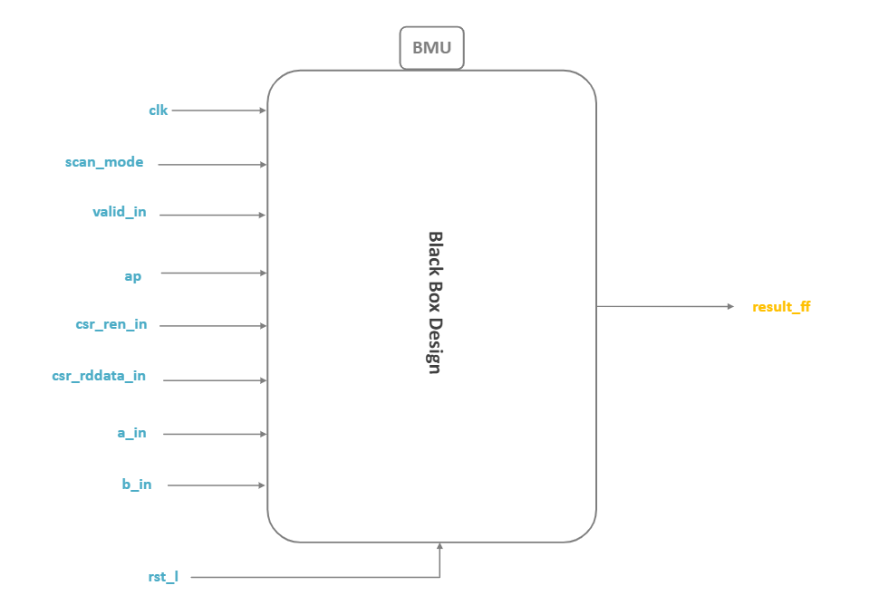

The interface and signals details are listed below in the table:

Interface
Signal | Width | Direction | Description
clk | 1 bit | input | Clock signal to the module
rst_l | 1 bit | input | Active-Low synchronous reset , reset all internal registers of the design to its initial state
a_in | 32 bits | input | Represents the first operand of BMU module
b_in | 32 bits | input | Represents the second operand of BMU module
scan_mode | 1 bit | input | Scan test mode control
valid_in | 1 bit | input | Instruction valid flag , indicate if the input instruction is valid or not
ap | Struct | input | Decoded instruction control signals (supported instructions by the BMU)
csr_ren_in | 1 bit | input | CSR read-enable
csr_rddata_in | 32 bits | input | CSR read data
result_ff | 32 bits | output | Final computed result
error | 1 bit | output | Error Indicator

Verification Strategy

Methodology
UVM will be used to

Selection of Verification Tests
Tests will cover all aspects of the BMU functionalities, including:

- logical Operations
This section defines logical operations performed by the BMU, primarily controlled by the ap.op field.The operation mode depends on the ap.Zbb extension bit to be asserted and requires all other control fields to be disserted.

  - Standard Bitwise OR Operation

  - Standard Bitwise Invertor OR Operation

  - Standard Bitwise XOR Operation

  - Standard Bitwise Invertor XOR Operation

- Shifting and Masking Operation
The Shifting and Masking operations include logical shifts, arithmetic shifts, rotates, and bit-level operations. Each operation is enabled by a dedicated control signal in the ap register. Only one shifting/masking operation should be active at a time, and all other ap.* fields must be 0, unless explicitly required by the operation.
  - Right Logical Shift Operation (SRL)

  - Right Arithmetic Shift Operation (SRA)

  - Rotate Right Operation ( ROR )

  - Bit Inverse Operation (BINV)

  - Shift Left by 2 and Add (SH2ADD)

- Arithmetic Operations
- Subtraction (a – b )

- Bit Manipulation Operations
- Set on Less Than (Unsigned SLT)

- Set on Less Than (SLT signed == default)

- Count Trailing Zero Bits (CTZ)

- Count Set Bits / Population Count (CPOP)

- Sign Extend Byte (siext_b)

- Maximum (max)

- Pack (pack)

- Byte-Reverse Register (grev)

- CSR operations

- Unsupported Opcode Handling

- Random cases

Testbench structure
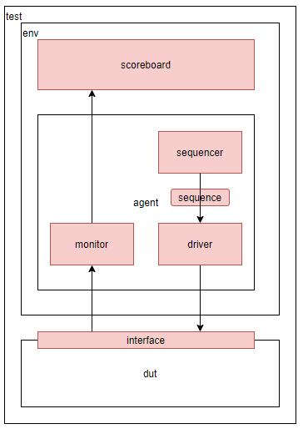

Tests
For each operation i will implement a test which contains all the pre-mentioned sequences

Coverage targets
- Code (line) coverage
- Functional coverage
- Toggle coverage
- Path coverage
- Cross coverage ( advanced , check multiple options once and for testing direct sequence .. )

Verification Extra Details

Components : driver , monitor , sequencer , sequence_item , agent , environment ,scoreboard , subscriber .
Interfaces: middle-ware interface between the DUT and the top testbench module

Tools and technologies:
- MobaxTerm Server .
- Intergrated Metrics Center (IMC) .
- Cadence Verisium for debugging .
- Visual Studio Code .

Regression Tests:
- Create Regression test to test all cases i have set up and run them together instead of running them individually in the top testbench module .

Coverage Reports: will be attached later

Verification Results: will be attached later

